Bring Visualizers on Mobile and your TV

# Introduction

#### Liquid takes the shape of the objects it’s placed in and flows around barriers and obstacles. Liquid Content leverages this concept allowing you to create content and deliver it in different channels and difference devices. Visualizers are the main tool to target that goal. It provides a great templating system that allows you to reuse content in different shapes on your web site.

Visualizer allows you to change how your content is presented in one place and automatically applied to all place in your site or external website in just one click.

However, the web site is just one of the many target channels. Nowadays more and more people use mobile apps and TV to consume content. Despite that, these channels present challenges for Content Editors and Content Managers:

1. How easily and fast I can connect my laptop or mobile to the TV to share and show content in meeting rooms or in public place
2. How can I update the presentation of the content in mobile application without re-deploy and re-distribute my application to all my customers

#### Here we will show you how Visualizer allows you to bring your content beyond the web site page going to Mobile Apps and Televisions and solve the above challenges.

You will learn how to implement a [Google Chrome Cast](https://www.google.com/intl/es_es/chromecast/) receiver and sender and use that from a Mobile App to send to your TV your Liquid Content with just one click. Also how with [Ionic Framework](https://ionicframework.com/) create a simple cross platform mobile app that interacts with Liquid Content and it is able to render in your smart phone or tables the same Visualizers you have in your web sites and update it automatically without the needs to re-deploy and/or re-distribute your mobile application to your customers.

# Solution

Liquid Content provides a great API that allows you to integrate with any applications and render the content using Visualizers.

This content can be rendered in a Web Browser and a Mobile App using HTML/CSS and javascript.

Once the content is your own device, with Google Chrome Cast we will cast it to your Television.

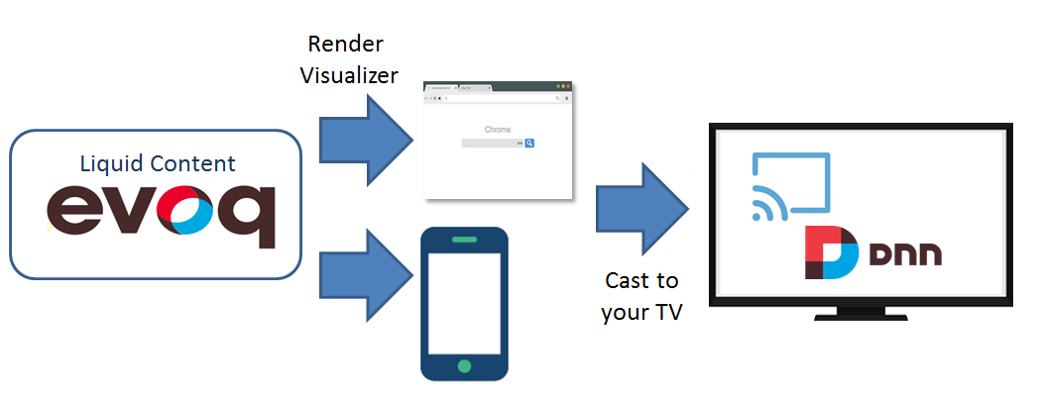

*Content Flow*

This solution is composed by 3 parts:

* **Visualizer Chrome Cast Receiver** (see [custom receivers](https://developers.google.com/cast/docs/custom_receiver)): simple web application responsible to handle the visualizer on your TV

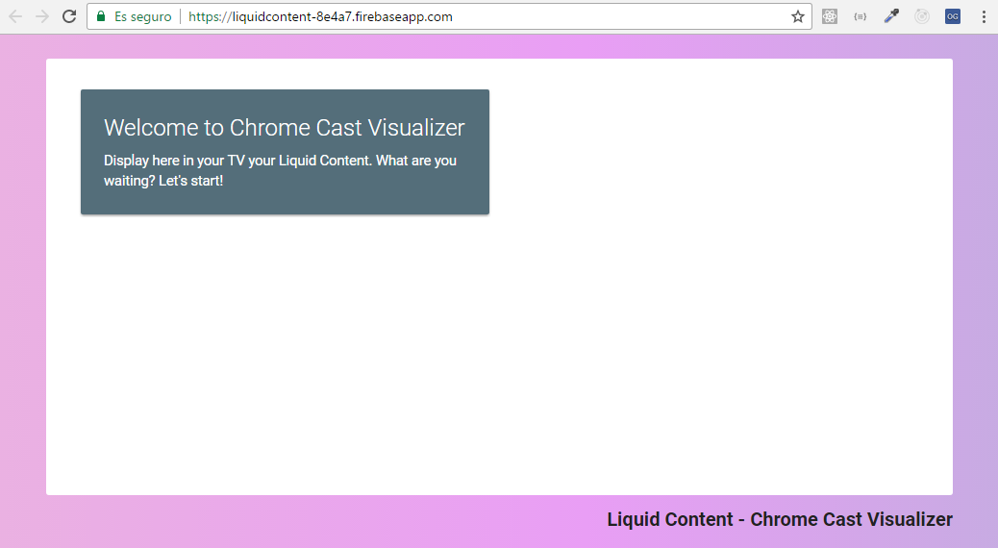

*Visualizer Chrome Cast Receiver*

* **Visualizer Mobile App**: mobile application able to render visualizer in mobile and cast to Google Chrome Cast

|  |  |  |
| --- | --- | --- |
|  |  |  |

*Ionic Mobile App Screenshots*

* **Visualizer Chrome Cast Dnn Module**: this latest is a basic example to how you can cast to Google Chrome Cast visualizer from your web site.

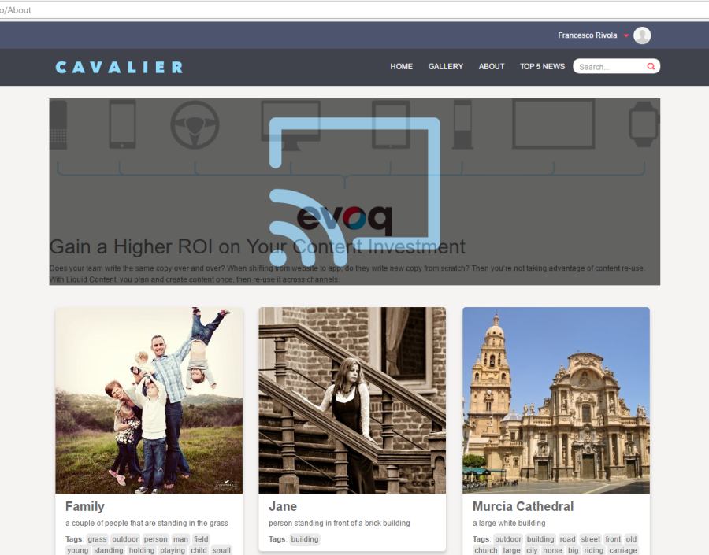

*DNN Cast Module*

Do you want to know more? Please follow [this link](https://github.com/dnnsoftware/Dnn.Evoq.LiquidContent.Samples/tree/master/Francesco/VisualizerChromeCast) for the full code and documentation step by step to how implement it. Enjoy!!!